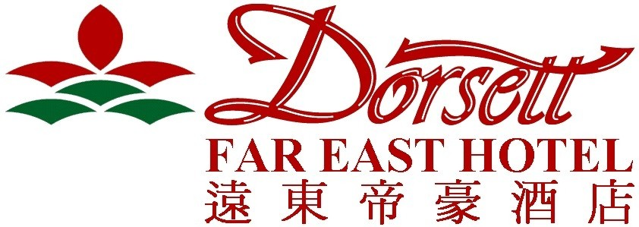

135-143 Castle Peak Road, Tsuen Wan, Kowloon, Hong Kong
Telephone: (852) 2406 9090 Fax: (852) 3657 2828
Internet: http://hongkonghotel.dorsettfareast.com.hk

Dear Delegates of “'The 6th Annual Asian Law Institute (ASLI) Conference”,
First of all, we would like to take this opportunity to thank you for choosing Dorsett Far East Hotel while you attend “'The 6th Annual Asian Law Institute (ASLI) Conference” in May 2009. We are pleased to offer special rates exclusively for your goodself for the period of 28–31 May, 2009 as follow:
Special Daily Rates:

Standard Room (One 4’x6’ Double Bed) - HK$ 440 per room per night (include a maximum of two breakfasts AND complimentary in-room internet access)

Standard Room (Two 3’x6’ Single Beds) - HK$ 440 per room per night (include a maximum of two breakfasts AND complimentary in-room internet access)

(The above rates are inclusive of 10% service charge and prevailing government tax)
For reservations, please complete the form printed below and return it to us by fax at (852) 3657 2929 or e-mail at hotel-fe@dorsettfareast.com.hk. Kindly note that the above special rates are only applicable for booking reserved on or before 9 April, 2009 and the confirmation of room space is subject to the hotel’s room availability and confirmation. Please be assured that credit card details are provided for guarantee purpose only. Please note that one night room charge per room will be applied for any no-show or cancellation made within 96 hours prior to the scheduled arrival date.
In the meantime, should you require any further information, please feel free to contact the undersigned at tel: (852) 3657 2835 or via e-mail: hotel-fe@dorsettfareast.com.hk.
We look forward to welcoming you at Dorsett Far East Hotel.
Yours sincerely,

Crystal Chan / Account Manager
Karen Tsang / Sales Coordinator

********************************************************************************************************
RESERVATION REPLY SLIP
To: Sales Department - Fax No: (852) 3657 2929 or E-mail: hotel-fe@dorsettfareast.com.hk

Conference Name | : | The 6th Annual Asian Law Institute (ASLI) Conference
Period of Stay | : | Date of Arrival _________________ |  | Date of Departure: ___________________
Guest Name | : | Mr. / Ms / Mrs _______________________________________________________
Accompany Guest (if any) | : | Mr. / Ms / Mrs _______________________________________________________
Room Type (please choose one) | : | □ Double Bed (for single or double occupancy)  □ Twin Beds (for single or double occupancy)
Special Room Request | : | □ Smoking Floor □ Non-Smoking Floor (subject to availability)
Flight Details | : | Flight Number ________________ | Expected Time of Arrival ________________
Credit Card Guarantee  (Please attach a copy of your credit card with both front and back sides) | : | By □ Visa □ Master □ American Express □ Diners
 |  | Name of Card Holder _________________________________________________
 |  | Card Number: ____________________ |  |  |  | Expiry Date: _____________________
Airport Pickup | : | □ HK$ 140 per trip per person (the service is provided by Hotelink)
Personal Information | : | Email Address ______________________________________________________
 |  | Phone Number ___________________ |  |  | Fax Number _____________________

