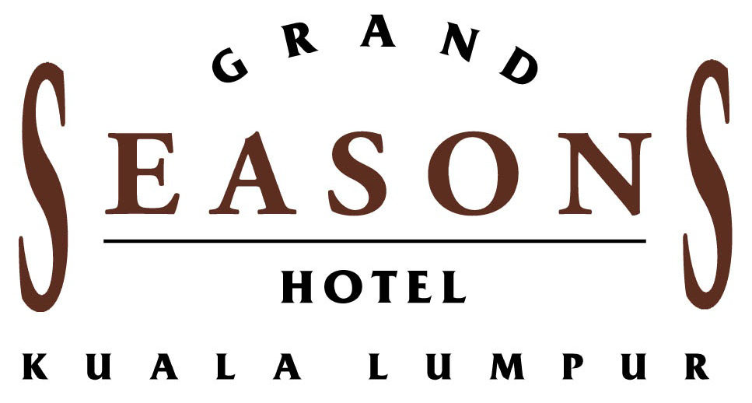
Reservation Form
“7th Asian Law Institute Conference”
24 – 27 May 2010
Venue: International Islamic University Malaysia

ROOM TYPE | SINGLE (NETT) | (√ ) | DOUBLE (NETT) | (√ ) | ROOM ONLY  W/OUT BREAKFAST (NETT) | (√)
Superior | RM190.00/USD55.00 |  | RM215.00/USD62.00 |  | RM180.00/USD52.00
Deluxe | RM215.00/USD62.00 |  | RM240.00/USD70.00 |  | RM190.00/USD55.00
Seasons Crest | RM265.00/USD77.00 |  | RM290.00/USD84.00 |  | RM230.00/USD67.00
Junior Suite | RM375.00/USD110
Seasons Suite | RM430.00/USD125
I would like to make the following reservation: (please tick)

Notes/Terms and Conditions:
- Room rates quoted are inclusive of 10% service charge and 5% government tax and complimentary buffet breakfast EXCEPT FOR ROOM ONLY/WITHOUT ANY BREAKFAST.
- The above rates are applicable for participants of this event only and effective within the stipulated event dates.
- Seasons Crest room is inclusive of broadband facilities with 15” LCD computer screen.
- Notification on cancellation must be given to the hotel not later than seven (7) days before check in date; otherwise a one (1) night’s room charge will be levied.
- Please guarantee your booking with credit card details. Failing which reservation will be accepted based on room availability.
- Check in is at 1500 hours. Rooms required before 1500 hours on the day of arrival on confirmed basis must be blocked. An additional 1 night room charge will be levied.
- Check out is at 1200 hours. Use of room after 1200 hours will be charged at full night room rate.Late check out is subject to availability.
- The hotel impose a penalty charge of equivalent to total room night charges blocked and confirmed,under the following situations; bookings made with early departure from the earlier check out date confirmed when making the reservations & bookings made with ‘no show’ at the hotel.
- 07 days prior to the arrival date, all guest rooms requirements should be received by the hotel. Requirement not confirmed will be released and further requests will be subject to space availability basis.
- In the event that cancellation/postponement is made after the deposit has been paid, where confirmation of the event is considered to be given, no refund shall be accorded.50% of total estimated revenue if cancellation/postponement is made after confirmation has been agreed upon.
- Cut off date for all reservations by 16 April 2010

Guest’s Name : ____________________________________________________
Company/Agency : ____________________________________________________
Address : ____________________________________________________
____________________________________________________
Telephone : ____________________ Fax : ________________________
Arrival Date : ___________________ Departure Date: __________________
Method of Payment: (please tick)
AMERICAN EXPRESS VISA MASTERCARD DINERS Others:_______________

Name of Card Holder : ___________________________________________
Credit Card No. : ___________________________________________
Expiry Date : ____________________ Specimen Signature : ____________________
*for American Express cardholder, please advice your non-embosed C.I.D number: ____________________

Please send this reservation request DIRECTLY to:

NORFADILAH HJ KASIM - SENIOR SALES MANAGER – GOVERNMENT ROOM DIVISION
WINNIE MASYITAH – SALES COORDINATOR – GOVERNMENT ROOM DIVISION
Grand Seasons Hotel I No 72, Jalan Pahang, 53300, Kuala Lumpur, Malaysia
Tel: 603-2697 8888 ext 8504/8510 I D/Line: 603-2695 5211 I Hp: 012 396 6774 I Fax: 603-2698 5888
Email: norfadilah@grandseasons.com Website :- www.grandseasons.com

