Recent
Passport-size
Photograph
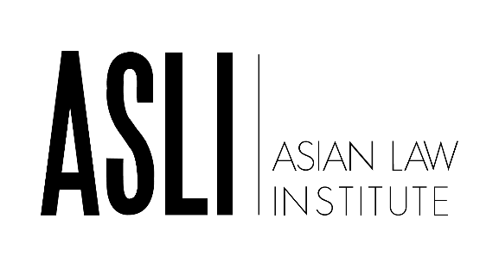
(Located at the Faculty of Law, National University of Singapore)

ASLI FELLOWSHIP PROGRAMME

< Application Form for Visits in 2024/2025 >
For faculty members from ASLI Member Institutions (including Founding Member Institutions)

[A] PERSONAL PARTICULARS
Name
Email Address
Gender |  | Male |  | Female
I confirm that I am employed full-time as a teacher at the institution indicated below and will continue to hold a full-time appointment during the proposed visit dates. |  | Yes |  | No
Name of ASLI member institution at which you are employed
Current title/position within member institution
(eg: Professor, Assistant Professor, Lecturer etc.)
[B] PREFERRED PERIOD OF FELLOWSHIP
In academic year 2024/2025, the Fellows may visit for a duration of 30 days during one of the two periods below.
Please indicate your preferred period for the Fellowship and note the following:

- The periods correspond with the NUS academic semester. Depending on the availability of Fellowship positions, we will try our best to accommodate your first choice.
- Successful candidates are required to be in residence in Singapore throughout the duration of the Fellowship.
Please indicate your first and second choice | Semester One  1 October 2024 to 8 November 2024 |  | Semester Two  3 March 2025 to 11 April 2025
This is my first choice
This is my second choice
I am not available during this period

[C] ENGLISH LANGUAGE PROFICIENCY
 |  |  | I am aware that English is the working language at the National University of Singapore Faculty of Law and hereby confirm that I am sufficiently proficient in English to present my paper, engage in discussions, as well as to write up my working paper in that language.
[D] PROPOSED RESEARCH
Proposed Research Area/Topic
The research project should be at a reasonably advanced stage by the time of the ASLI Fellowship.
ASLI Fellows are expected to present their research at a staff research seminar at NUS and submit a completed draft for the ASLI Working Paper Series within one month of the end of the Fellowship. In the space below, please describe (using no more than 500 words) the research that you propose to undertake and present at the seminar during the Fellowship (and the resulting paper that you will be submitting to the ASLI Working Paper Series).
Proposed Title of Seminar to be given during Fellowship
[E] OTHER SUPPORTING DOCUMENTS
I have attached the following documents to support my application:

Curriculum Vitae (CV) which contains the following:
- Personal Particulars
- Educational & Professional Qualifications
- Working Experience
- Research Interest
- Teaching Interest

Publication List of my writings and research
- First, list your publications
- Then, if you wish, you may list your unpublished papers
- Please state which publications are in English and if available, please forward us one sample of a publication, or paper presented, in English.

[F] DECLARATION BY APPLICANT
I declare that the particulars in this application form are true to the best of my knowledge and belief, and I have not wilfully suppressed any material fact.

 |  | Signature |  |  |  | Date
[G] SUPPORT OF APPLICATION BY APPLICANT’S INSTITUTION HEAD/ DEAN
Please comment briefly on the applicant’s suitability for the ASLI Fellowship Programme.

I support the application of the above applicant and would grant leave from our university for the selected duration of the fellowship if the applicant is selected for the ASLI Fellowship Programme.

Signature: |  |  |  |  | Date:
Name: |  |  |  |  | Email Address:
Designation:

Important Notes:

- Interested applicants are strongly advised to submit this application form along with the required supporting documents to the ASLI Secretariat via email to: asli@nus.edu.sg at least one week ahead of the stated deadline.

- Some of the candidates may be interviewed, in particular to check their ability to communicate in English and to present an academic paper in English.

- If the applicant is selected, the ASLI Secretariat will email him/her additional forms required for his/her visit to the National University of Singapore. The applicant should complete and return the forms along with other required documents via email within two weeks of receipt of the forms.

- ASLI reserves the rights to cancel or postpone the date of your visit if applications for your visa and/or other immigration permits are delayed or denied.

- ASLI Fellows are required to be in residence in Singapore throughout the duration of the fellowship.

